The terms *task*, *job*, *deployment*, and *stage* are commonly used in the context of software development, DevOps, and CI/CD pipelines. Here's an explanation of each term:

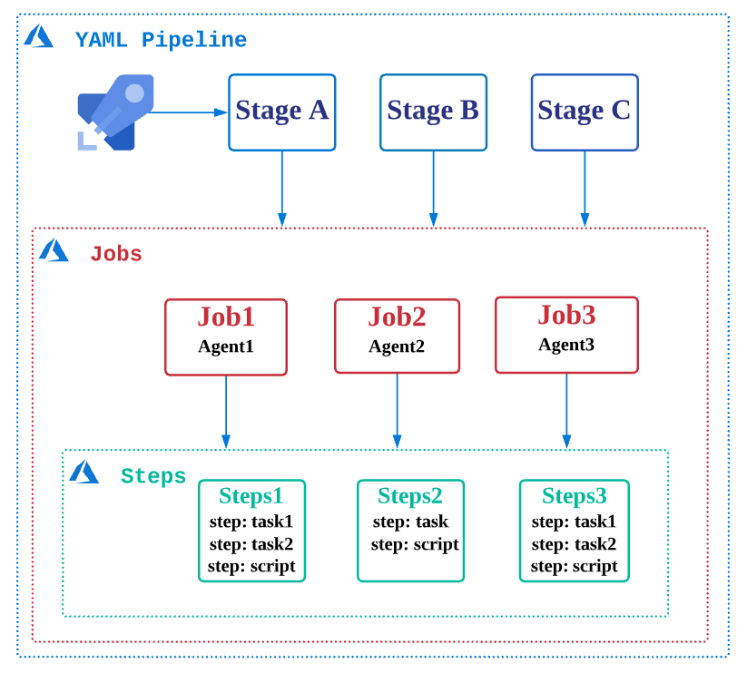

**1. Task**

* **Definition**: A single, specific action or piece of work within a larger process.
* **Examples**:
  + Running a script.
  + Compiling code.
  + Running a test suite.
* **Context**:
  + In CI/CD, tasks are often the basic building blocks of a pipeline.
* **Tools**:
  + In Jenkins, tasks can be part of a *job*.
  + In task runners like Gulp or Grunt, tasks are defined as repeatable units of work.

**2. Job**

* **Definition**: A collection of tasks that are executed together as a unit.
* **Examples**:
  + A CI pipeline might define a *build job* that compiles code and runs unit tests.
  + A *test job* could run integration or acceptance tests.
* **Context**:
  + Jobs are used in CI/CD pipelines to structure the flow of execution.
* **Tools**:
  + Jenkins: A job defines a CI/CD task such as a build or deploy.
  + GitLab CI: A job is a single unit of work in a pipeline stage.

**3. Deployment**

* **Definition**: The process of delivering a specific version of software to a target environment (e.g., development, staging, production).
* **Examples**:
  + Deploying a web application to a production server.
  + Updating a mobile app on app stores.
* **Deployment Strategies**:
  + **Blue-Green Deployment**: Switch between two environments to minimize downtime.
  + **Canary Deployment**: Gradually release new features to a subset of users.
  + **Rolling Deployment**: Incrementally update parts of the system without downtime.
* **Tools**:
  + Kubernetes, Docker, AWS CodeDeploy, and GitHub Actions.

**4. Stage**

* **Definition**: A logical grouping of jobs within a CI/CD pipeline, representing a phase in the software delivery lifecycle.
* **Examples**:
  + **Build Stage**: Compiles the code.
  + **Test Stage**: Runs automated tests.
  + **Deploy Stage**: Deploys the build to a target environment.
* **Context**:
  + Stages are executed in sequence or parallel depending on the pipeline design.
* **Tools**:
  + GitLab CI: Stages like build, test, deploy.
  + Jenkins: Can define stages using declarative pipelines.

**Summary of Their Relationships:**

* **Tasks** are the smallest unit of work.
* **Jobs** group tasks together.
* **Stages** group jobs in the pipeline.
* **Deployments** occur as part of a stage or job, delivering software to specific environments.